CT30A3204 Advanced Web Applications
Project work

Juho Koski 00116431
26.2.2026

Mandatory requirements
- Implementation of backend with Node.js
  - Yes Node.js handles the backend with express
  - Express used to route user and it handles requests and response. JWT doesn’t work without express.
  - UI 100% in english
- Utilization of database
I used MongoDB because I was already familiar with it.
- Authentication
New users have to register first and then login to start using the system. They can also log out. Authenticated user can remove own and shared files. Deleting a shared file removes permissions for that file.
JWT was used because it was used earlier in the course and it was easy to implement
- Features
  - Authenticated users can:

Add new documents and edit them. Documents can be removed and shared to other users. Owner of the document can give editing and viewing permissions to other existing users. Owner has an extra option to share documents with viewing rights to any user via link. The link has to be pasted to input field found in home page.
This app uses react quill-new editor. It was easy to install and there were tutorials how to use it.
This helped installing: https://www.npmjs.com/package/react-quill-new
and this is the documentation how I learned how to use it: https://github.com/VaguelySerious/react-quill?tab=readme-ov-file

Two users cannot edit same document at the same time. I created document locking system which turned out to be more difficult than I initially thought. If user tries to open document that another is using an alert pops up and with message: “someone else is editing the document”. If the user returns to home page or closes the tab the other user can access the document.
The locking system uses MongoDB’s findAndModify function which is an atomic operation and is recommended to use when dealing with locks.
Help implementing locking: https://www.mongodb.com/community/forums/t/locking-documents-in-mongo/6865
https://www.architecture-weekly.com/p/locks-queues-and-business-workflows

The user can also log out.

  - Non-authenticated users can register and login
If someone gives non- authenticated user a link to a document. He / she can view the document but not edit it.

- Responsive design
The app uses Bootstrap. I accidentally installed Bootstrap for JS but it worked most of the time very well. I only had to manually change some of the variable names such as class to className. Smooth header animations stopped working.

- Documentation

How to start
Navigate to project folder and write npm install and then npm run dev. This starts client and server at the same time.

Technology choices

- Concurrently was used to start both client and server at the same time. Helped so I did not have to start server and client separately.

- Project uses React. Typescript is used on the backend and frontend. Vite handles proxy between frontend and backend.

- Choosing MongoDB was easy because I was already familiar with it. And Mongoose handles what data is going to be stored to MongoDB.

- Nodemon handles server reboots as soon as it detects changes to files. There's no reason why I wouldn't use it.

- React router Dom enabled routing.

- Bootstrap CSS was chosen mainly because it had better documentation than MaterializeCSS.

- Text editor React-Quill-New the choice because it was React version of normal Quill. It was also newer than React-Quill. This was the first editor that came when I searched one.

- Morgan provides HTTP request information. This worked for me.

- JsonWebToken used for authentication. It was easy to implement because I had used it before.

declaration of AI usage:
    - 1) Name all AI systems that were used in the development of the contents of this document, and for each
ChatGPT, Gemini?
    - 2) How and where they were used (illustrations, proofreading, getting ideas for text, to generate diagrams etc.)
I had installed bootstrap for JS and not for REACT so I asked ChatGPT if it mattered. It said it does work but there might be some issues with bootstrap components. I still decided to stay in the JS version.
Sometimes when I pasted error messages to google into to find more information and a solution to the problem, the AI overview told me the solution.

Points proposal

Feature | Max points
Basic features (as stated in the previous chapter) with well written documentation | 25
Utilization of a frontside framework, such as React, but you can also use Angular, Vue or some other | 3
The document editor includes wysiwyg editor of some sort (e.g. https://quilljs.com/, https://editorjs.io/, https://draftjs.org/) | 2
The drive shows besides the name of the document also the creation and last updated timestamp | 1

Weird bug that appeared:
There was a weird bug when I tried to implement the React-quill-new text editor. There appeared a weird line on the screen. After trying to find a fix to it for couple hours. I tested if the same bug appeared on different browser. It appeared in Chrome but not in Edge. I found a solution to that here: https://stackoverflow.com/questions/19779605/3d-css-transform-translatez-causes-elements-to-disappear-in-chrome . I had to add transform: translateZ(0); to Home.css file. That should force the browser to use GPU hardware acceleration.

Gallery and user manual

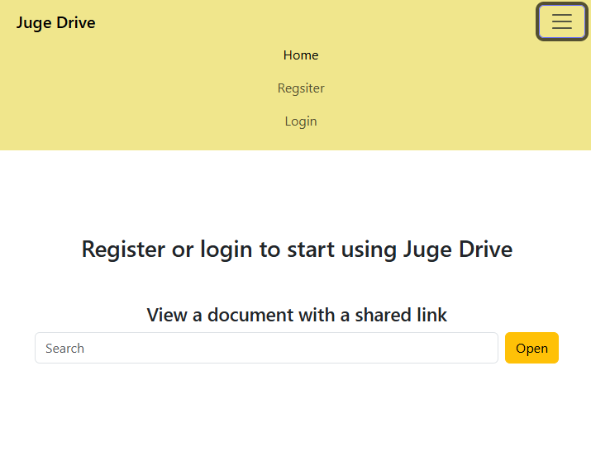
Figure 1 Home page

When user opens the app, he / she comes to this page. Shared links can be pasted here. User can Register and Login here.

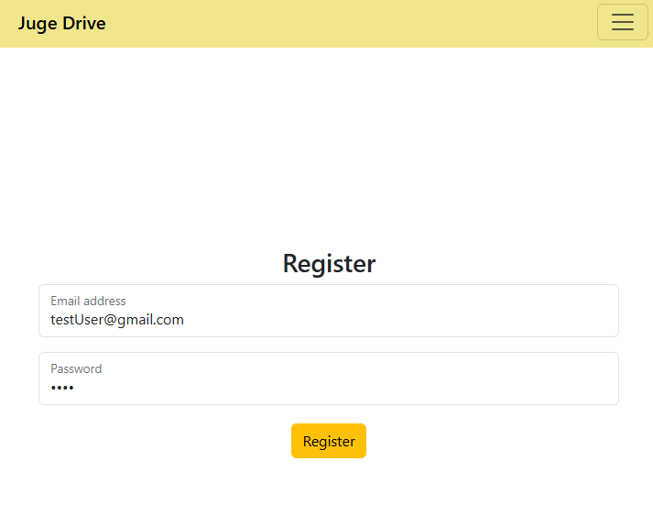
Figure 2 Register page

After pressing Register button, user can give their email address and password. After user presses register. he gets routed to Login page.

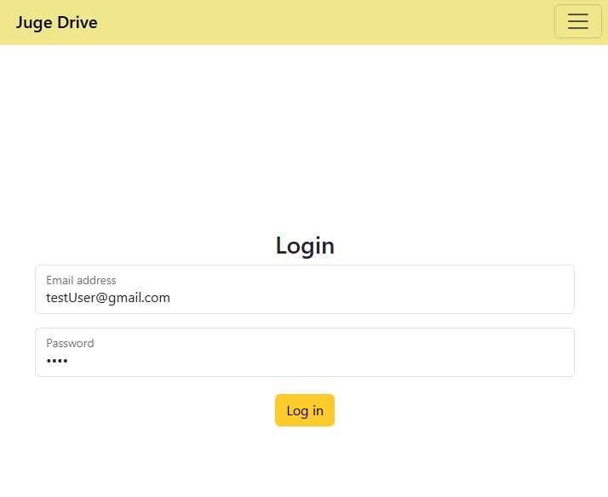
Figure 3 Login page

Now the user has to give their credentials again to start using the application.

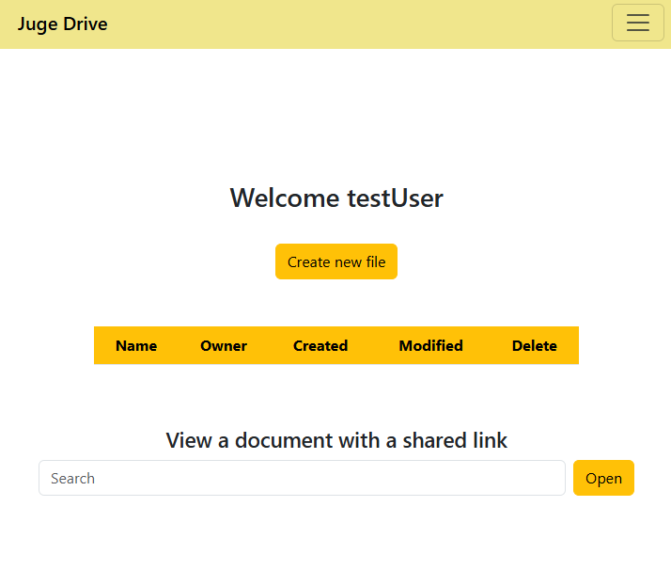
Figure 4 Home page when logged in

New users home page looks something like this. User can still view other documents via link.

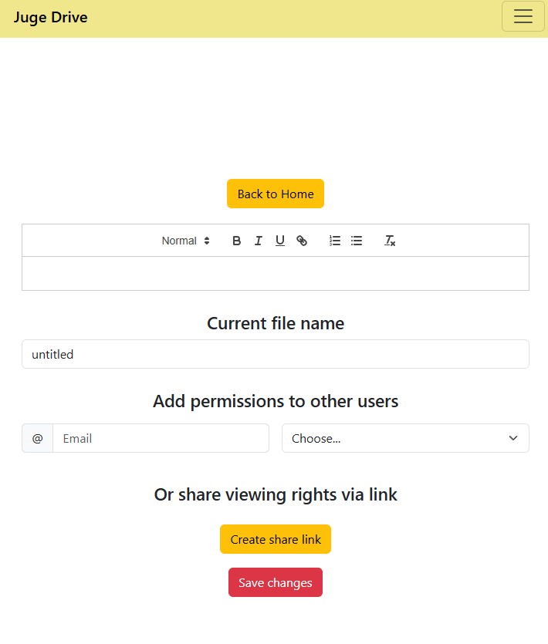
Figure 5 Edit document
after pressing Create new file button the view should look like this. Now user can give file name, start writing and give other existing users writing or viewing permissions to this file. If the user presses Create share link, a field will pop up where they can copy and send a link to their friend. The link is opened by pasting it into the input field on the home page.

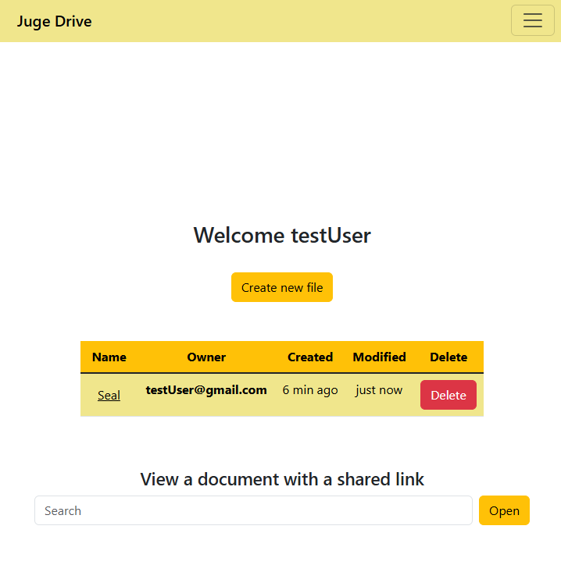
Figure 6 New document

There is now a new document. If the user wants to delete it, that is possible. By pressing the Name of the document, In this case Seal the user can edit the document again.

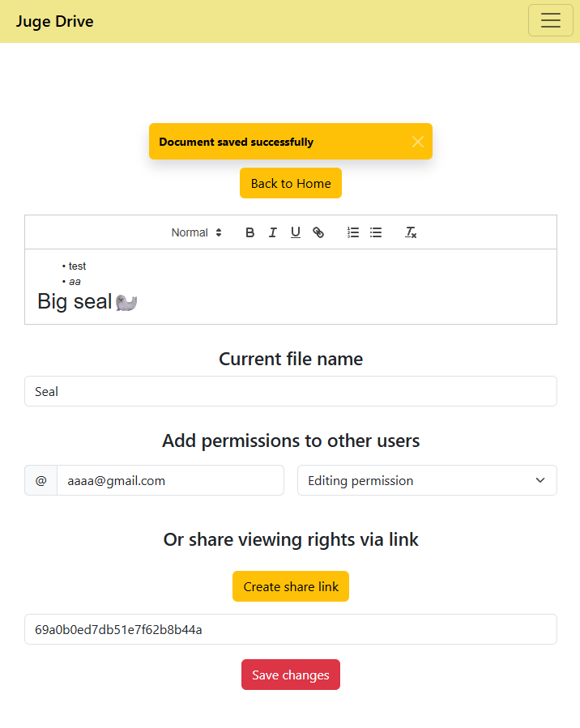
Figure 7 Document edited

Now I added editing permission to aaaa@gmail.com that was an existing test user. The share link can be also seen when it was clicked. Remember to save the changes.

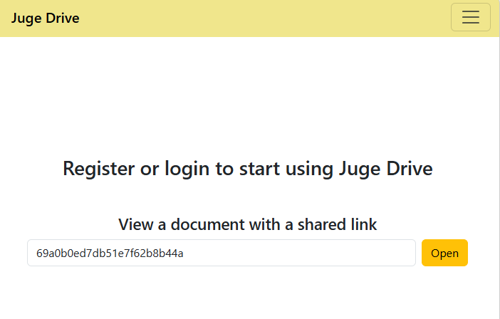
Figure 8 Link test with new user

Now there the link can be tested with new user. this user is not logged in. By pressing the open button it can view the Seal document but not edit it.
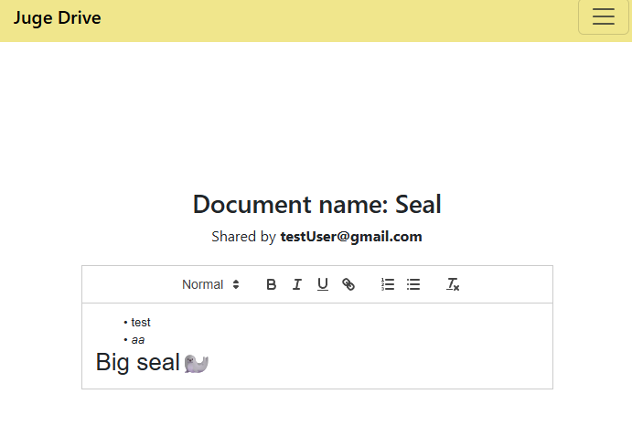
Figure 9 Viewing rights via link
Now the user can view the document but cannot do anything else to the document.

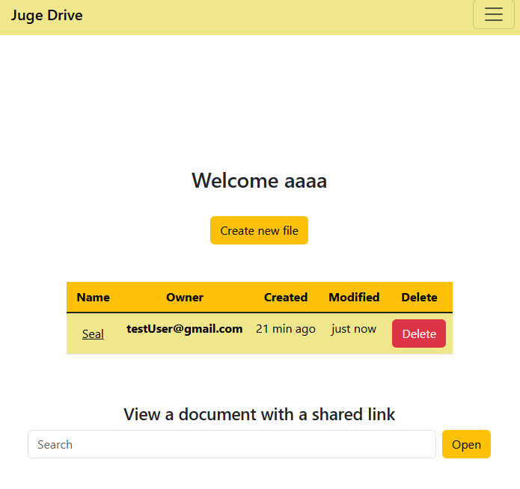
Figure 10 permissions granted
testUser gave editing permissions to aaa@gmail.com. Now he can also edit that file but not at the same time.

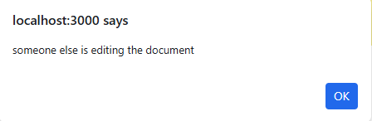
Figure 11 someone is editing the document

testUser is editing the document so aaaa cannot access the file

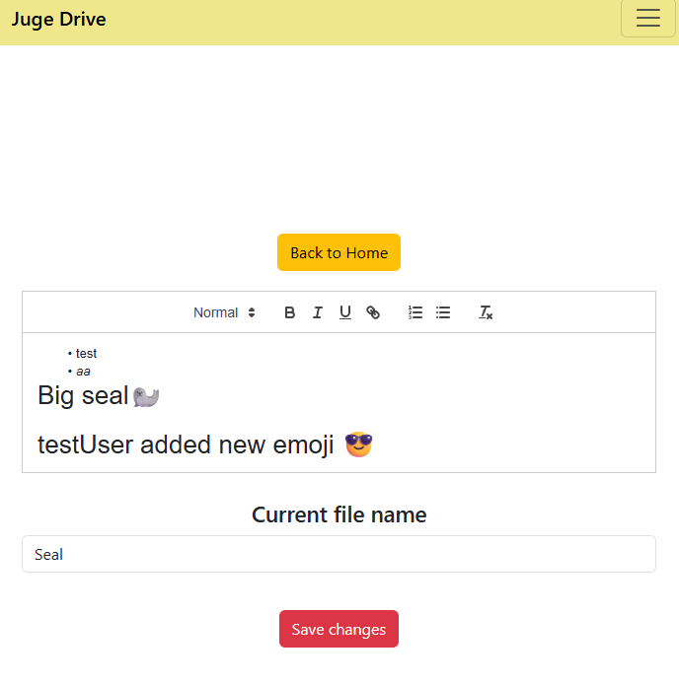
Figure 12 Document lock opened

Now testUser stopped editing the document and aaaa can see the file.

Sources:
Sources are also commented in the code

React quill-new text editor: https://www.npmjs.com/package/react-quill-new
React quill-new documentation: https://github.com/VaguelySerious/react-quill?tab=readme-ov-file

Bootstrap docs: https://getbootstrap.com/docs/5.3/getting-started/introduction/
Bootstrap warning color: https://getbootstrap.com/docs/5.1/utilities/colors/
Bootstrap navbar: https://getbootstrap.com/docs/5.3/components/navbar/
Bootstrap toasts: https://getbootstrap.com/docs/5.3/components/toasts/#live-example
Bootstrap editing tables: https://getbootstrap.com/docs/5.3/content/tables/#overview

date function from previous project: https://bitbucket.org/juho_koski/full-stack_juho_koski/src/master/MERN-Project/

help with res status codes: https://developer.mozilla.org/en-US/docs/Web/HTTP/Reference/Status

sendBeacon help:
https://developer.mozilla.org/en-US/docs/Web/API/Navigator/sendBeacon
https://stackoverflow.com/questions/79416970/navigator-sendbeacon-vs-fetch-keepalive-reliability-upon-browser-or-tab-close

mongoose model help: https://mongoosejs.com/docs/typescript.html

Helped creating unloadHanlder that releases document locks when user closes tab: https://codesandbox.io/p/github/chasoft/react-beforeunload-ts/main

string manipulation: https://stackoverflow.com/questions/46570887/split-string-in-javascript-reactjs
array updating: https://react.dev/learn/updating-arrays-in-state
some() function: https://www.geeksforgeeks.org/typescript/typescript-array-some-method/
creating AuthContext: https://www.youtube.com/watch?v=h3_YKC2VGfE

